CNT4703C

9/2019

# Lab 7

**IP Addressing (v4 and v6)**

1. **Answer the following questions about TCP/IP.**

* 1. What is NAT? How is it used?

NAT = Network Address Translation. It is responsible for translating multiple IP’s of computers in a local network to a single public address. There are a limited number of IP’s available and using NAT allows the creator of a network to only need one address for routing, while setting any device they please to any IP they desire without collision being a concern.

* 1. What is a socket? What is a port? What is port 21 used for? What about port 53?

Socket – any endpoint of a two way connection that goes between two applications on a network.

Port – a number assigned to a virtual point where network connections occur; it functions similarly to an ID.

Port 21 is used for FTP and connection handling.

Port 53 is used for DNS.

* 1. How does DNS work? What would happen if we didn’t have DNS?

DNS works by managing the mapping between names and numbers. Essentially, it works kind of like Google Maps. All the ‘locations’ are stored, along with how to get there, and it’s accessible to others. Without it, computers wouldn’t have access to websites or other live services.

* 1. What it BootP used for?

Bootstrap Protocol is used for automatically setting an IP to a network user’s machine based on a configuration server.

* 1. What is DHCP? How does it make the network admins life easier?

DHCP – Dynamic Host Configuration Protocol – is a protocol that automatically assigns IP’s as needed. This cuts down on network administrators’ stress as they no longer have to manually assign everything.

* 1. What is a “lease” of a DHCP derived address?

A lease is a temporary assignment of an IP to a network-connected device.

* 1. What is WINS? How does it differ from DNS?

WINS - Windows Internet Name Service – is a troubleshooting service that associates computer names with IP’s. WINS uses the name directly, as opposed to DNS using domains, to resolve IP’s.

* 1. What tools/commands can be used to troubleshoot TCP/IP?

Netstat, ipconfig, tracert, ping, arp.

* 1. How does FTP differ from TFTP?

The difference is primarily on the user’s location. FTP is remote and sends data over a TCP connection while TFTP is inside a network (connectionless) and sends between network devices.

* 1. How many “nodes/hosts” would the following IP v4 addresses support?

1. 207.30.155.0

Class C network => (2^18)-2 = 254

b.123.56.0.0

Class A => (2^24)-2=16,777,214

* + 1. 56.0.0.0

Class A => 224-2=16,777,214

* 1. Based on the following IPv4 addresses list the default subnet mask for each address and the network address and node/host address:
     1. 201.210.59.87

Subnet: 255.255.255.0

Network Address: 201.210.59.0

Host Address: 201.210.59.0/24

* + 1. 56.112.87.191

Subnet: 255.0.0.0

Network Address: 56.0.0.0

Host Address: 56.0.0.0/8

* + 1. 112.158.2.104

Subnet: 255.0.0.0

Network Address: 112.0.0.0

Host Address: 112.0.0.0/8

* + 1. 192.158.75.89

Subnet: 255.255.255.0

Network Address: 192.158.75.0

Host Address: 255.255.255.0/24

* + 1. 228.195.128.241

Subnet: none

Network Address: 192.158.75.0

Host Address: 192.158.75.0/24

* 1. What are the following IPv4 addresses used for?

1. 127.0.0.1

localhost

b.255.255.255.255

broadcast address

* + 1. 244.122.89.3

Multicast groups in a local network

d.127.255.255.255

loopback

* 1. Convert the following IPv4 addresses to Binary.

1. 89.112.45.3

01011001. 01110000. 00101101. 00000011

b.158.89.112.101

10011110.01011001.01110000.01100101

* + 1. 189.56.147.125

01011001.00111000.10001111.01111101

* + 1. 10.251.178.238

00001010.11111011.10110010.11101110

1. **Network Design using IPv4 Addressing**

* 1. If you were tasked with setting up a geographic network and you needed at least 7 network addresses and had an IP network address of 190.152.0.0 what would you do? Assign valid IP addresses to the following sub-networks for each city, with the appropriate subnet mask:

Pensacola:

Sub: 255.255.240.0

Network address: 190.152.0.0

Tampa:

Sub: 255.255.224.0

Network address:190.152.160.0

Tallahassee:

Sub: 255.255.224.0

Network address: 190.152.32.0

Orlando:

Sub: 255.255.224.0

Network address: 190.152.128.0

Miami:

Sub: 255.255.224

Network address: 190.152.128.0

Daytona:

Sub: 255.255.224.0

Network address: 190.152.96.0

Jacksonville:

Sub: 255.255.224.0

Network address: 190.152.96.0

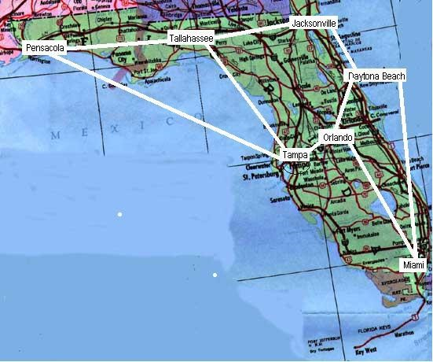

1. **IPv6 Addressing (same as module notes).**

• Representing Full (Unabbreviated) IPv6 Addresses o IPv6 uses a hexadecimal format for addressing.

o The address is made up with 8 sets of four hex digits with each set of four digits separated by a colon.

▪ For example: 2340:1111:AAAA:0001:1234:5678:9ABC:1234 ▪ There is also a binary version of the number as well.

o The table below shows the values from decimal – hexadecimal – binary.

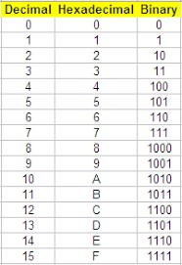

* Abbreviating and Expanding IPv6 Addresses o IPv6 addresses can be abbreviated o Abbreviating IPv6 Addresses
  + Leading zeros can be removed from each quartet of hex digits.
  + 0000 can be abbreviated as just 0
  + Double colons can be used when two or more consecutive quartets can be replaced by a double colon

o Example:

* + IPv6 address – FE00:0000:0000:0001:0000:0000:0000:0056
  + Can be abbreviated as – FE00:0:0:1:0:0:0:56

•

It can be abbreviated more

–

FE00:0:0:1::56

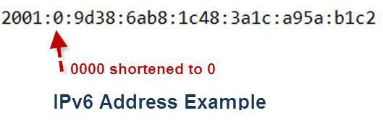

* + Expanding Abbreviated IPv6 Addresses
* To expand an IPv6 address back to its full 32-digit number.

o Add back leading zeros until each quartet has 4 digits. o If multiple colons exist, add 0000 quartets until 8 quartets are showing.

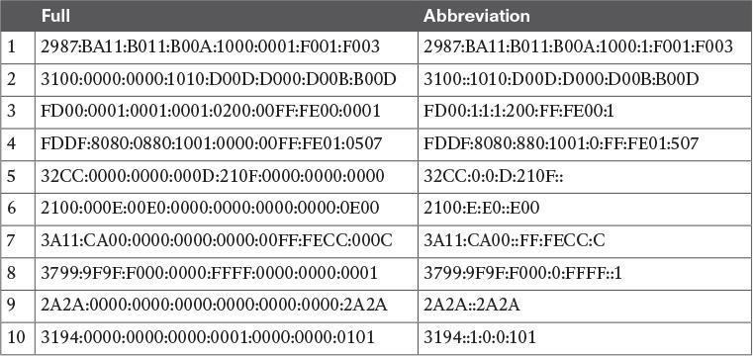

▪ Representing the Prefix Length of an Address

* IPv6 uses a mask concept called the prefix length.
* For an address with a 64-bit prefix length, it can be written as:

o 2222:1111:0:1:A:B:C:D/64 o 2222:1111:0:1:A:B:C:D /64 o The prefix length can be from 0 through 128

▪ Calculating the IPv6 Prefix (Subnet ID)

• To compute the prefix length (or Subnet ID) for /P then: o Copy the first P bits

o Change the rest of the bits to 0

* The example below shows the conversion o Identify the number of hex digits divide by 4 (so 64/4 = 16) o Copy the hex digits determined to be in the prefix o Change the rest of the hex digits to zero

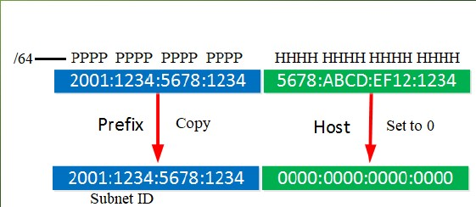

* For example the following IPv6 address can be converted as follows:
* 2000:1234:5678:9ABC:1234:5678:9ABC:1111/64
* Divide 64/4 = 16; so the first 16 bits is the subnet ID o 2000:1234:5678:9ABC:0000:0000:0000:0000/64

• Working with more difficult IPv6 prefix lengths o For example: 2000:1234:5678:9ABC:1234:5678:9ABC:1111/56 o Divide 56/4 = 14; so the first 14 hex digits are the prefix length (subnet ID). o The conversion would be: 2000:1234:5678:9A00:0000:0000:0000:0000/56 o It can be abbreviated as: 2000:1234:5678:9A00::/56

**Problems:**

1. Convert the following IPv6 addresses into their full length:
   1. **1522:8765:21::/48**

**1522:8765:0021:0000:0000:0000:0000:0000**

* 1. **1789:1011:0::/64**

**1789:1011:0000:0000:0000:0000:0000:0000**

* 1. **FE80::0202:B3FF:FE1E:8329/56**

**FE80:0000:0000:0000:0000:0202:B3FF:B329**

* 1. **::/128**

**0000: 0000: 0000: 0000: 0000: 0000: 0000:0000**

* 1. **2002:64C8:64C8::/64**

**2002: 64C8:64C8:0000:0000:0000:0000:0000**

* 1. **2001:cdba::3257:9652**

**2001:CABA:0000:0000:0000:0000:3257:9652**

1. Convert the following IPv6 addresses into their compressed format:
   1. **FE80:0000:0000:0000:0202:B3FF:FE1E:8329**

**FE80::202:B3FF:FE1E:8329**

* 1. **2001:0db8:85a3:0000:0000:8a2e:0370:7334**

**2001:DB8:85A3::8A2E:370:7334**

* 1. **2041:0000:130F:0000:0000:07CO:853A:140B**

**2001:0DB8:85A3::8A2E:0370:7334**

* 1. **2001:cdba:0000:0000:0000:0000:3257:9652**

**2001:CDBA::3257:9652**

* 1. **fe80:0:0:0:200:f8ff:fe21:67cf**

**FE80::200:F8FF:FE21:67CF**

* 1. **2001:0000:3238:DFE1:0063:0000:0000:FEFB**

**2001:0:3238:DFE1:63::FEFB**